V4.2 Toy Model 2
Quantum-Side Close-Out Paper
Two-State Projection, Bell Correlations, Decoherence, Measurement Update, Erasure, and Macroscopic Irreversibility
Rev A | Date: 2026.05.25 | 6D Projection Framework exploratory formalization track
Status: Toy Model 2 is closed as a quantum-side compatibility chapter. It shows that the reciprocal projection architecture can be written in standard quantum notation without immediately violating basic quantum constraints. It does not derive Quantum Mechanics, the Born rule, Hilbert space, or physical 3T existence.
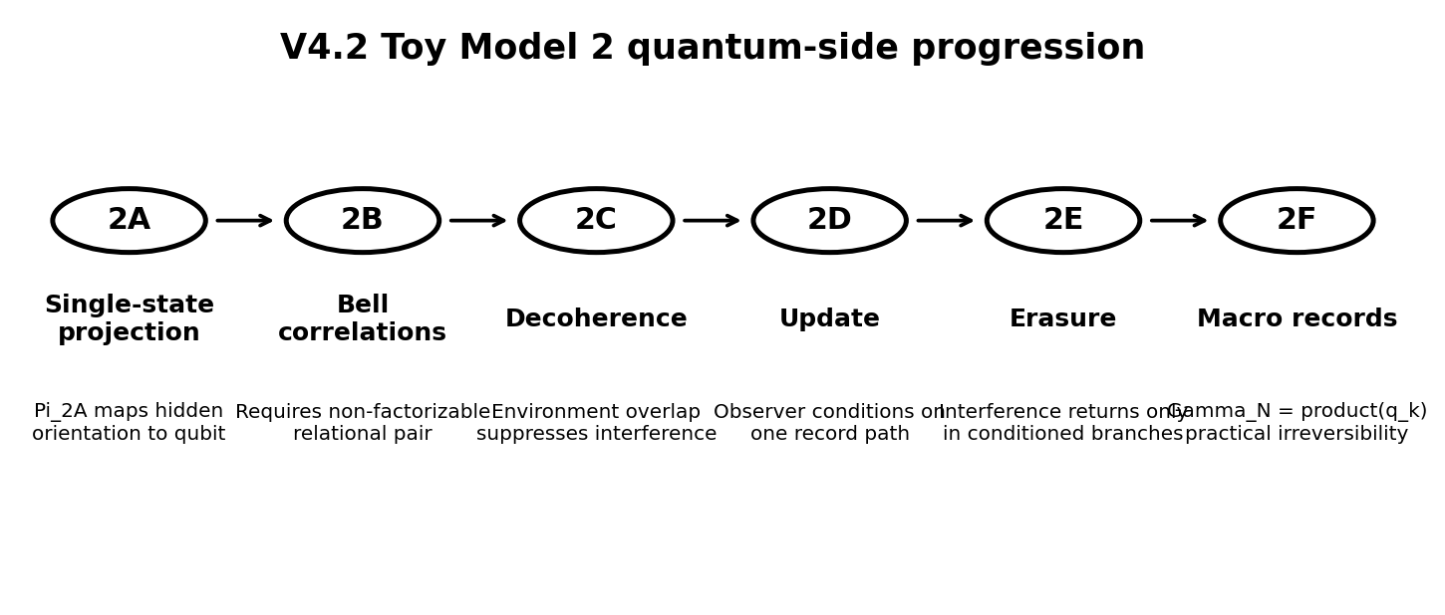
Figure 1 - Toy Model 2 quantum-side progression.

1. Executive close-out
Toy Model 2 was designed to test the quantum-side part of the 6D Projection Framework after the graph-geometry work of Toy Model 1D. The working question was whether a hidden 3T relational structure can be projected into observer-accessible 1T quantum behaviour while respecting the strict constraints of standard quantum mechanics.
The answer from Toy Models 2A through 2F is limited but useful: the architecture survives first-contact compatibility tests for a single qubit, Bell correlations, decoherence, observer update, quantum-erasure logic, and macroscopic irreversibility. The chapter does not derive quantum theory from first principles.
Official result: Toy Model 2 supports the V4.1 principle Relationship -> Organization -> Observable Order on the quantum side in the limited sense that relational projection can be made compatible with selected standard quantum structures. It is a compatibility bridge, not a completed physical theory.

2. Core architecture being tested
The assumed architecture was:
Parent structure: 6D = 3 spatial degrees + 3 temporal-relational degrees
Observable sector: 3S + 1T
Hidden relational sector: 3T + 1S
Projection target: hidden 3T relational structure -> observer-accessible 1T quantum records
The minimal projection notation is:
psi_obs = Pi(Psi_3T)
- Psi_3T means the hidden temporal-relational state.
- Pi means the projection operator or projection rule.
- psi_obs means the observer-accessible state description.
- The 1T observer does not access the full hidden relational structure directly; they see restricted records and probabilities.

3. Summary table of Toy Models 2A-2F
Model | Target | Main survival result | Main guardrail
2A | Two-state reciprocal projection | Hidden 3D orientation maps to a qubit-like spinor and preserves normalization. | Born rule compatibility only; no derivation.
2B | Two-particle Bell correlations | Naive anti-aligned local arrows fail; surviving model requires a non-factorizable relational pair. | Not a local hidden-variable model; no proof of 3T.
2C | Decoherence as projection stabilization | Environment overlap gamma suppresses off-diagonal interference terms. | Decoherence is not collapse.
2D | Measurement update and single-outcome constraint | Selective local update can be treated as observer-record conditioning. | Does not solve why this outcome is experienced.
2E | Interference recovery and erasure | Interference returns only in conditioned eraser branches; unread average unchanged. | No retrocausality, no FTL signalling.
2F | Macroscopic irreversibility | Gamma_N = product(q_k) gives exponential practical irreversibility. | No fundamental information destruction.

4. Toy Model 2A - Two-state reciprocal projection
Toy Model 2A tested the smallest possible quantum structure: a two-state system, or qubit. The hidden 3T state was represented by a normalized direction vector n with spherical angles theta and phi.
n = (sin(theta) cos(phi), sin(theta) sin(phi), cos(theta))
|n| = 1
The candidate projection was:
Pi_2A(n) = |psi(n)> = cos(theta/2)|0> + exp(i phi) sin(theta/2)|1>
- theta controls the probability balance between |0> and |1>.
- phi preserves phase information needed for interference.
- exp(i phi) is a complex phase with magnitude 1.
- The half-angle theta/2 is the standard spinor relation between a direction on the Bloch sphere and a two-state quantum amplitude.
The Born-compatible probabilities are:
P(0) = |alpha|^2 = cos^2(theta/2)
P(1) = |beta|^2 = sin^2(theta/2)
P(0) + P(1) = 1
2A close-out: Pi_2A is compatible with two-state quantum amplitude geometry, probability normalization, qubit rotations, and minimal no-signalling checks. It does not derive the Born rule; it uses the Born reading rule.

5. Toy Model 2B - Bell correlations and non-factorizable relational pairs
Toy Model 2B tested whether entanglement could be treated as two independent hidden orientations pointing in opposite directions. That naive version failed.
Naive hidden model:
n_A = n
n_B = -n
Result after isotropic averaging:
E_naive(a,b) = -(a dot b) / 3
Standard quantum mechanics requires the singlet correlation:
E(a,b) = -a dot b = -cos(theta_ab)
Therefore, Toy Model 2B forced an important correction: the hidden 3T pair cannot be treated as two independent local hidden arrows. The surviving projection must treat the pair as one non-factorizable relational object.
|psi_singlet> = (|01> - |10>) / sqrt(2)
P(s_A, s_B | a,b) = 1/4 [1 - s_A s_B (a dot b)]
E(a,b) = P(++) + P(--) - P(+-) - P(-+) = -a dot b
This reproduces the CHSH quantum value |S| = 2 sqrt(2) while preserving local no-signalling marginals.
2B close-out: Bell compatibility is possible only when the hidden pair is relational and non-factorizable. This supports the 6D intuition that entanglement is relational proximity, but it does not prove physical 3T existence.

6. Toy Model 2C - Decoherence as projection stabilization
Toy Model 2C tested how a quantum state becomes classical-looking when it couples to environment records. The starting point was:
(alpha|0> + beta|1>) |E_ready>
-> alpha|0>|E_0> + beta|1>|E_1>
The key quantity is the environment overlap:
gamma = <E_1 | E_0>
- gamma = 1 means the environment records are identical; interference remains visible.
- gamma = 0 means the environment records are fully distinguishable; local interference disappears.
- 0 < gamma < 1 means partial decoherence.
The observer-accessible reduced density matrix becomes:
rho_S = [[ |alpha|^2, alpha beta* gamma ],
[ alpha* beta gamma*, |beta|^2 ]]
As gamma approaches zero, the off-diagonal interference terms vanish locally while the diagonal Born probabilities remain unchanged.
2C close-out: decoherence can be interpreted as projection stabilization: phase information is dispersed into environment records and becomes inaccessible to the 1T observer. Decoherence is not collapse.

7. Toy Model 2D - Measurement update and single-outcome constraint
Toy Model 2D separated global evolution from local observer update. After decoherence, the local reduced state is approximately diagonal:
rho_S = [[ |alpha|^2, 0 ],
[ 0, |beta|^2 ]]
The selective local observer update was written as the standard Luders update:
rho -> rho_k = P_k rho P_k / Tr(P_k rho)
The compatible global record state was written:
|Psi_SEO> = alpha |0>|E_0>|O_0> + beta |1>|E_1>|O_1>
In the 6D interpretation, the global relational state is not physically destroyed. The 1T observer conditions on one record path. The nonselective update preserves the probability structure and does not change the remote marginal state in an entangled pair.
2D close-out: single-outcome experience can be modeled as local 1T observer-record conditioning without global physical collapse or faster-than-light signalling. This does not solve why this observer experiences this specific outcome.

8. Toy Model 2E - Interference recovery and erasure constraint
Toy Model 2E tested quantum-erasure logic. The starting state was:
|Psi_SE> = alpha|0>|E_0> + beta|1>|E_1>
If |E_0> and |E_1> are distinguishable, the local observer sees no interference. The eraser basis is:
|E_+> = (|E_0> + |E_1>) / sqrt(2)
|E_-> = (|E_0> - |E_1>) / sqrt(2)
Conditioned on the eraser result, the system state becomes:
|psi_+> = alpha|0> + beta|1>
|psi_-> = alpha|0> - beta|1>
Thus interference can return in conditioned subensembles. But if the eraser outcome is unread, the plus and minus branches average back to the same decohered state.
2E close-out: quantum erasure is phase-recombination after correct conditioning, not retrocausality or time travel. Without the sorting key, no local signal or interference recovery appears.

9. Toy Model 2F - Macroscopic irreversibility and record stability
Toy Model 2F extended the environment from one record to N records:
|Psi_SE> = alpha|0>|E_0^(1)>...|E_0^(N)>
+ beta |1>|E_1^(1)>...|E_1^(N)>
For each environment record subsystem:
q_k = <E_1^(k) | E_0^(k)>
The total environment overlap is:
Gamma_N = product(q_k)
If all overlaps are identical:
Gamma_N = q^N
The reduced state is:
rho_S = [[ |alpha|^2, alpha beta* Gamma_N ],
[ alpha* beta Gamma_N*, |beta|^2 ]]
As N grows, visible interference is exponentially suppressed. This defines a practical record-stability threshold, not a fundamental collapse threshold.
q | N for |Gamma_N| < 1e-6 | Meaning
0.9 | 132 | Strong per-record distinction; fast stabilization.
0.99 | 1,375 | Weak but accumulating records.
0.999 | 13,809 | Very weak records still become stable at large N.
0.9999 | 138,149 | Extremely weak records require many environmental degrees.
2F close-out: macroscopic irreversibility is practical/statistical. The global relational information is not destroyed, but the control required to recombine the record field grows beyond realistic 1T access.

10. Integrated mathematical ladder
Across 2A-2F, the quantum-side ladder can be summarized as:
2A: hidden 3D orientation -> two-state spinor
2B: hidden relational pair -> non-factorizable singlet structure
2C: environment overlap gamma -> suppression of interference
2D: observer record conditioning -> local single-outcome update
2E: eraser conditioning -> recoverable interference in sorted subensembles
2F: many record overlaps -> Gamma_N = product(q_k) -> practical irreversibility
This ladder is structurally consistent with the V4.1 organizing principle:
Relationship -> Organization -> Observable Order
In the quantum chapter, relationship means hidden relational structure; organization means projection into amplitudes, entanglement, and record correlations; observable order means the 1T observer-accessible sequence of outcomes and stable classical records.

11. Formal guardrail consolidation
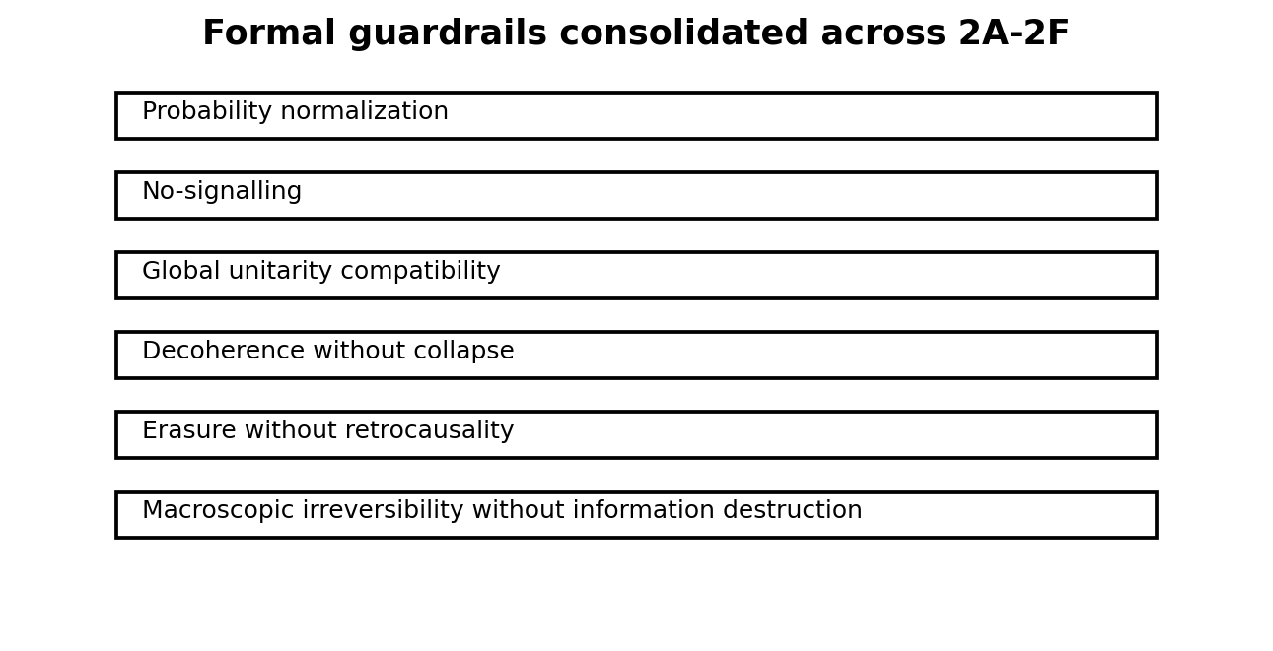
Figure 2 - Guardrails preserved across Toy Models 2A-2F.
The following guardrails are now locked:
- Do not claim that Toy Model 2 derives Quantum Mechanics.
- Do not claim that the Born rule has been derived. It has been used and checked for compatibility.
- Do not claim that hidden 3T physical existence has been proven.
- Do not claim a local hidden-variable theory. Toy Model 2B explicitly rejects the naive local anti-aligned version.
- Do not claim that decoherence is collapse. Decoherence suppresses accessible interference.
- Do not claim retrocausality from quantum erasure. Erasure works only after conditioning/sorting.
- Do not claim fundamental information destruction in macroscopic irreversibility.
- Do not claim new predictions yet.

12. What was actually achieved
The achievement is not a finished theory. The achievement is a compatibility bridge. Toy Model 2 shows that the reciprocal projection architecture can be written in standard quantum language and can survive first-order consistency tests.
Achieved | Not achieved
A candidate single-qubit projection operator Pi_2A. | A derivation of Hilbert space from 6D geometry.
Rejection of the naive local hidden anti-aligned model. | A local hidden-variable explanation of Bell correlations.
A non-factorizable relational interpretation of entanglement. | Proof of physical 3T existence.
Decoherence modeled as loss of accessible phase information. | A solution to single-outcome selection.
Measurement update modeled as local observer-record conditioning. | A derivation of the Born rule.
Quantum eraser compatibility without retrocausality. | A new experimental prediction.
Macroscopic irreversibility as exponential record dispersion. | A full quantum field theory or Standard Model connection.

13. What may be genuinely new versus restated standard QM
Much of Toy Model 2 deliberately restates standard quantum mechanics in controlled notation. That is necessary for compatibility. The possible new structural claim is not the equations themselves, but the interpretation of why the equations appear:
Possible new structural claim: quantum amplitudes, entanglement, decoherence, erasure, and classical record stability may be interpreted as restricted 1T projections of a richer hidden relational-temporal organization.
This claim remains speculative until it produces one of the following:
- a derivation of complex amplitude structure rather than assuming it;
- a derivation of Born-rule weights rather than using them;
- a formal projection operator from a richer 3T object to Hilbert space;
- a recoverable link to relativistic quantum field theory;
- a new testable deviation or explanatory compression beyond standard quantum mechanics.

14. Risk register
Risk | Severity | Mitigation
The work is only a re-description of standard QM. | High | Explicitly label compatibility versus derivation.
Projection operator is too close to the Bloch-sphere parameterization. | High | Next target must explain origin of complex amplitudes or Hilbert structure.
Framework becomes unfalsifiable. | High | Define comparison targets and possible failure criteria before extending to cosmology.
Overclaiming Bell compatibility as proof of hidden 3T. | High | Keep 2B wording: non-factorizable projection is compatible, not proven physical.
Measurement update mistaken for solving collapse. | High | Keep 2D guardrail: local conditioning is not a full measurement solution.
Macroscopic irreversibility mistaken for fundamental collapse. | Medium | Keep 2F guardrail: practical/statistical irreversibility only.

15. Recommended next research chapter
The next useful chapter should not jump immediately to black holes or the dark sector. The quantum-side work has one obvious hard target: explain what has so far been assumed.
Recommended next chapter: Toy Model 3A - Origin of Complex Amplitudes and Hilbert-Space Structure from Reciprocal Projection.
Target questions for Toy Model 3A:
- Why should the projected observer-accessible state be complex-valued rather than merely real-valued?
- Can the phase factor exp(i phi) be derived from orientation around the hidden 3T axis?
- Can inner products and Hilbert-space norm be interpreted as projection-invariant relational quantities?
- Can the Born-rule square norm be motivated from projection geometry rather than inserted?
- Where does Toy Model 2 merely rename standard quantum mechanics, and where does it add structure?
Only after this should the framework return to harder physical targets such as black holes, horizon entanglement, dark matter, or dark energy.

16. Official Toy Model 2 close-out statement
Toy Model 2 successfully closes as a quantum-side compatibility chapter. From 2A through 2F, the reciprocal projection architecture was tested against single-qubit structure, Bell correlations, decoherence, local measurement update, quantum-erasure logic, and macroscopic irreversibility. The chapter shows that selected quantum phenomena can be represented coherently inside the 6D Projection Framework using standard quantum mathematics and strict guardrails. It does not derive Quantum Mechanics, Hilbert space, the Born rule, the Standard Model, or physical 3T existence. The strongest result is that the architecture survives basic quantum compatibility checks and identifies the next hard target: deriving or motivating complex amplitudes and Hilbert-space structure from the projection mechanism.

17. Short rebind prompt for future continuation
We are resuming after V4.2 Toy Model 2G - Quantum-Side Close-Out.
Toy Model 2A-2F closed as a compatibility chapter:
2A: Pi_2A maps hidden 3D relational orientation to a two-state spinor.
2B: naive anti-aligned local hidden arrows fail; surviving Bell-compatible model requires a non-factorizable relational pair.
2C: decoherence is modeled by environment overlap gamma suppressing off-diagonal terms.
2D: measurement update is modeled as local observer-record conditioning, not global physical collapse.
2E: quantum erasure restores interference only in conditioned branches; unread averages preserve no-signalling.
2F: macroscopic irreversibility is modeled by Gamma_N = product(q_k), giving exponential practical record stability.
Guardrails:
No derivation of QM, Born rule, Hilbert space, Standard Model, or physical 3T existence.
No retrocausality, no faster-than-light signalling, no local hidden-variable model, no fundamental information destruction.
Next recommended chapter:
Toy Model 3A - Origin of Complex Amplitudes and Hilbert-Space Structure from Reciprocal Projection.

